Osvaldo Borsani’s Revolutionary Effect on Furniture Design

Final Essay

Hamna Shahzad (2019190211)

CDM 2007-01: History of Modern and Contemporary Design

Professor Myung Min Son

Monday, June 20, 2022

**Introducing Osvaldo Borsani: the mastermind behind Tecno furniture**

Born in 1911 in Varedo, Italy during the start of Italian modernism, Osvaldo Borsani was one the key figures to have revolutionized Italian furniture[1]. He started making furniture at a young age owing to his familial Art Deco style furniture making business and in around 1953, Borsani created his own furniture company called “Tecno” alongside his brother Fulgenzio[2]. After going through the Rationalist movement of the 1930s, Borsani was much more practical and visionary in his approach where he was “equally interested in the mechanics of mass producing his furniture and objects as he was in creating one-off designs, which set him apart from his purely artisanal contemporaries[3].” Indeed, this interest in the mass production and individuality of his designs is what makes Borsani an iconic Italian furniture designer especially when it comes to experimenting in both Art Deco styles with minimalist geometric designs as well as the new technology-based designs of the rationalist movement.

Borsani’s constant experimentation, however, does not mean that he does not have a signature style. Even though Italian modernism was going through a rather critical moment in design history with the Fascist regime and Italian Rationalism, Borsani had a typical style focused on innovation and comfort. Certainly, after World War 1 at a time when Italians yearned for national unity and strong discipline, Italian furniture design also strongly adhered to traditional designs. Borsani’s approach, however, differed where he strived to create new technological types of furniture that had the strong structure of his predecessor designers but also a unique identity that differed from previous works. The key part to achieving this difficult middle ground of tradition and novelty in design is through both the material of the furniture and the quality of individualism of the product. Sparke in her essay on “Craft and Design in Italy”, noted that the high quality of Borsani’s products was only possible because there was an “emergence of the Fordist mass-production/mass-consumption model[4].” This design model allowed “several collaborations between architects and small-scale manufacturers” which Borsani followed by collaborating with iconic designers like Lucio Fontana and this resulted in the considerable modernization and reorganization” of products for Borsani’s Tecno company[5]. Borsani’s forward thinking in quickly competing with the industrially mass-produced furniture business while retaining his own authenticity established him as a novel designer. Other designer critics like Norman Foster, however, believe that Borsani was actually one of a kind due to his hard work in almost every facet of the furniture design making process: “In today's world we have designers who design, manufactures who craft the design, behind them probably entrepreneurs who coordinate the work, and at the end there is somebody who is responsible for the branding. When we look at Osvaldo Borsani's career, we realize that he did all these things — even before the word “brand” existed.” Borsani’s dedication to Tecno as a multi-faceted furniture designer has, in turn, produced a great deal of popular product designs that have been revered by Tecno patrons and design critics to this day.

**The structure of the iconic P40 chair**

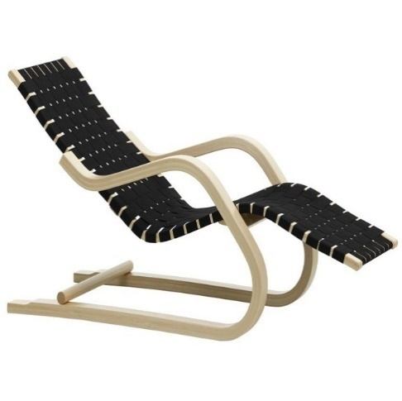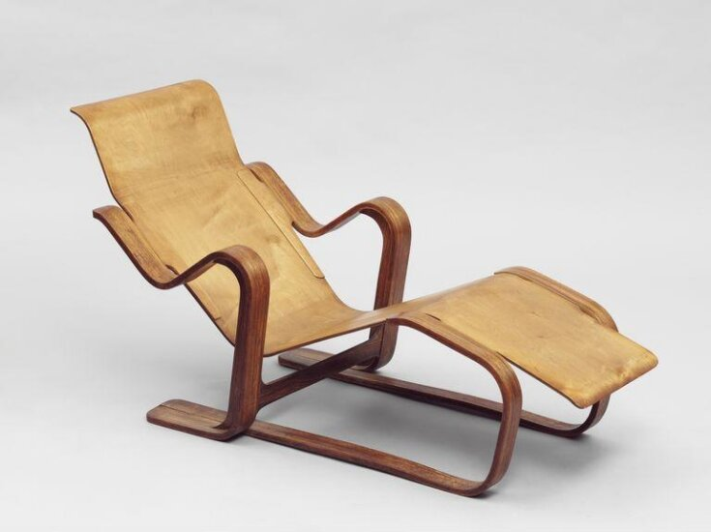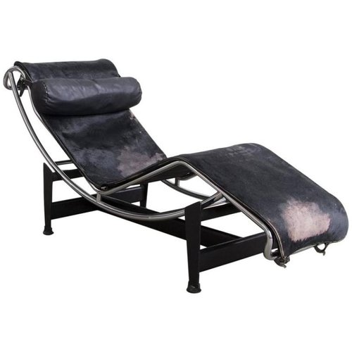Created by Borsani in 1955, the P40 chair is one of Tecno’s most longstanding and popular chair designs to date. Traditionally meant to be a simple lounge chair, Borsani sought to individualize it by focusing on the comfort and reclining nature of the chair in various positions to ensure optimum freedom in movement. As confirmed by the company itself, the P40 chair is made of “enameled steel, brass, rubber and upholstery fabric” and “boasts the ability to adjust in 486 positions” as well as possess a “sleek silhouette, articulated frame, and elegant sculpted form.[6]” According to the Tecno website, P40 is novel not only due to its unique reclining design but also its multi usability in various settings such as house, office, public buildings, or even perhaps outdoor places. P40 is particularly important to describe Borsani’s design trajectory and prowess because lounge chairs were trending during the 1950s and many furniture designers like La Corbusier, Marcel Breuer, and Alvar Aalto had already made lounge chairs.

Indeed, while the lounge chair aspect has been done before Borsani had formed his P40 creation, it had not been subject to the same level of quality material and reclining position as now. For instance, while La Corbusier’s LC 4 Chaise Longue Chair was made to be a resting chair with a curved spine, a built-in cushion rest and even an underneath supporting racks to ensure the chair does not topple; the chair seems to also be extremely uncomfortable in its structure. The choice of thin leather or Ragazine material with a metal handle seems to be entirely non-supportive to lie down for extended periods of time while there seems to be the glaring problem of inability to change the resting positions. Similarly, the lounge chairs by Breuer and Aalto while meant to be light weight in structure and aesthetically pleasing in design are rather thin and extremely uncomfortable in the fixed reclining positions they offer. Tecno on the other hand prioritizes comfort in their design with their state-of-the-art reclining system that has a “metal pedestal which supports the seat and backrest which are pivoted to permit all possible angles” and it also includes “a foldaway element under the seat that can pivot outwards to provide extended leg support and incorporates a pull-out metal footrest.[7]” For the P40 chair , besides the helpful ability to recline in countless positions, Borsani guarantees the comfort by creating winged handles with heavy upholstery fashioned out of foam-rubber. Additionally, Borsani lets out his minimalist art deco style by choosing to create a smaller metal fan legs support for the chair to ensure that the chair remains lightweight and easily accessible. In order to fit the taste of a wider range of customers, Tecno has even chosen to release the chair in assorted colors including black, red, orange, yellow and grey with the metal legs being painted only in grey or copper gold. By offering a wide array of options, Borsani has created an even more targeted range of customization for his patrons. Consequently, this allows for design critics to understand the P40 chair as more than just a standard Italian artisan furniture piece or even a more revolutionary mass-produced design. Instead of offering a good, Borsani offers a novel experience with his P40 chair that is customized with minute details of his artisanship scattered around.

**How Borsani’s P40 legacy is being reinterpreted**

As a result of the ideological and structural influence of the P40 chair, many other designers like Gio Ponti, [Achille Castiglioni](https://www.pamono.com/designers/achille-pier-giacomo-castiglioni), and even Noboru Nakamura from Ikea sought to construct their own versions of lounge chairs. In particular, Ikea’s Poäng chair gained a cult following and remains popular to this day. The reason Borsani is indirectly responsible for Nakamura’s and hence Ikea’s Poäng design is because it has a similar structure and design philosophy with its U- shaped cantilever plywood design. Noboru Nakamura’s design process of the Poäng chair revolves around it being a source of comfort and structural novelty just like the P40 chair: “A chair shouldn’t be a tool that binds and holds the sitter; it should be a tool that provides us emotional richness. [Poäng] creates an image where we let off stress or frustration by swinging. Such movement has meaning and value.[8]” Ikea’s dedication to preserving the essence of their Poäng chair has allowed them to diversify their chair collection by allowing for more customization options for colors and materials which is similar to Borsani’s vision for the P40 chair and Tecno furniture in general.

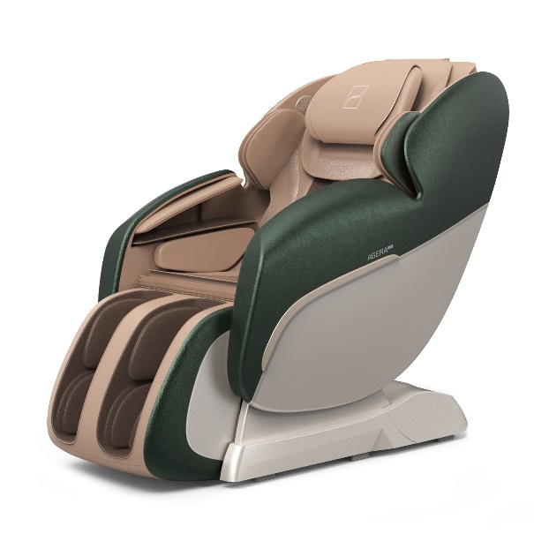 Moving on from Borsani’s immediate influence on Ikea through the P40 chair in the 1960s, more recent contemporary lounge and recliner chairs. Borsani’s goals of making the P40 chair into a technologically comfortable invention has brought in inventions of recliner chairs that not only provide optimum comfort but various facilities like massage and heating settings, USB charging ports, cup holders, counter balanced lift systems and water-resistant microfiber. A recent example of these kinds of technologically advanced versions of Borsani’s modest P40 chair could even be the ones from the South Korean massage chair company healthcare company, “Bodyfriend.”

Admittedly, while Bodyfriend may not be able to embody the minute craftsmanship characteristics of Borsani’s P40 chair because of the added facilities and different target audience. However, it is still valid to consider it a reinterpretation of Borsani’s original lounge chair because the goal of providing comfort with increased “tech creativity” is shared among the design process of both design companies.

**Overview: Borsani’s other popular works**

Aside from his exceptionally well received P40 chair, Borsani was also praised for his sofa designs especially that of his D70 patented divan bed that he created in 1953. This divan bed allowed Borsani to push the tech savvy and comfort-based image of Tecno into the mainstream industry. D70’s innovation and elegance lies in its “two pivoting wings, a metal frame, polyurethane foam filling, and fabric or leather upholstery” where “the opening mechanism consists of a lever with a securing pin that engages with holes in a graduated plate.[9]” This allows the divan bed to work easily with “a practical knob” that shifts the “backrest and seat to assume A picture containing text, indoor, wall, table
any angle and to fold down to form a bed.[10]”

D70’s unique bed and sofa combination is perhaps only superseded by Borsani’s wildly popular and cult-favorite “Graphis” desk. According to Techno themselves on their website, the Graphis desk created a frenzy in the furniture market and inspired future office desk design he original where it was made out of “three basic elements: a white painted “L” shaped sheet metal frame, a drawer unit and a laminate worktop” and as time passed, “the Graphis system has been expanded by the addition of other elements including containers, corners, meeting tables, screens and audio-video tables[11].” In addition to its sleek and minimalist matte design, what makes the Graphis desk such an iconic and integral part of Borsani’s work is the fact that it is actually a *system* and a set of building blocks.

A key element of Borsani’s furniture is most aptly his dedication to providing a future room for addition and improvement whether it be through customizing colors or indirectly inspiring other furniture designers to reinterpret his designs. Borsani’s work is actually a work of art in itself because his work are not only a part of iconic furniture history but also a building block for future designers and even manufactures from other less related categories such as tech massage chairs nowadays. This is perhaps the reason to why Barsoni has established himself and his company as a longstanding brand that has stood to the test of the rather harsh Italian modernism for designers and has emerged out with a distinct signature design. This signature design of Barsoni stays true to both his Italian roots and yet has an individualized and revolutionary perspective on furniture design.

**Bibliography**

Sparke, Penny. “The Straw Donkey: Tourist Kitsch or Proto-Design? Craft and Design in Italy, 1945-1960.” *Journal of Design History* 11, no. 1 (1998): 59–69. http://www.jstor.org/stable/1316163.

Osvaldo Borsani. “Osvaldo Borsani.” www.tecnospa.com. Accessed June 20, 2022. <https://www.tecnospa.com/en-us/company/architects-and-designers/osvaldo-borsani>.

Foster, Norman. “Norman Foster: Why Osvaldo Borsani Was a Design Pioneer - CNN Style.” CNN. edition.cnn.com. Accessed June 20, 2022. <https://edition.cnn.com/style/article/norman-foster-on-osvaldo-borsani/index.html>.

Hass, Nancy. “Outside Milan, a Living Testament to the Powers of Italian Modernist Design (Published 2019).” www.nytimes.com, August 8, 2019. <https://www.nytimes.com/2019/08/08/t-magazine/osvaldo-borsani-home-varedo.html>.

Nast, Condé. “Enjoy Osvaldo Borsani’s Retrospective at Triennale Design Museum Milan.” Architectural Digest India. www.architecturaldigest.in, May 21, 2018. <https://www.architecturaldigest.in/content/design-icon-osvaldo-borsani-triennale-design-museum-milan/>.

Sparke, Penny. "‘A Home for Everybody?’: Design, Ideology and the Culture of the Home in Italy, 1945–72." In *Culture and Conflict in Postwar Italy*, pp. 225-241. Palgrave Macmillan, London, 1990.

“BODYFRIEND.” www.bodyfriend.com. Accessed June 20, 2022. <https://www.bodyfriend.com/>.

YouTube. “Interview with Noboru Nakamura.” youtu.be, July 29, 2016. <https://youtu.be/_QKvvoy9z7Q>.

Edwards, Clive. "Reclining Chairs Surveyed: Health, Comfort, and Fashion in Evolving Markets." *Studies in the Decorative Arts* 6, no. 1 (1998): 32-67.

DONZELLA. “Osvaldo Borsani.” www.donzella.com. Accessed June 20, 2022. <https://www.donzella.com/oswaldo-borsani>.

Fast Company. “Poäng: The Little-Known History Of Ikea’s Most Famous Chair.” www.fastcompany.com, September 1, 2016. https://www.fastcompany.com/3063312/poaeng-the-little-known-history-of-ikeas-most-famous-chair.

1. Foster, Norman. “Norman Foster: Why Osvaldo Borsani Was a Design Pioneer - CNN Style.” CNN. edition.cnn.com. Accessed June 20, 2022. <https://edition.cnn.com/style/article/norman-foster-on-osvaldo-borsani/index.html>.
2. Osvaldo Borsani. “Osvaldo Borsani.” www.tecnospa.com. Accessed June 20, 2022. <https://www.tecnospa.com/en-us/company/architects-and-designers/osvaldo-borsani>.
3. Hass, Nancy. “Outside Milan, a Living Testament to the Powers of Italian Modernist Design (Published 2019).” www.nytimes.com, August 8, 2019. <https://www.nytimes.com/2019/08/08/t-magazine/osvaldo-borsani-home-varedo.html>.
4. Sparke, Penny. “Craft and Design in Italy.” Pg. 8
5. Sparke, Penny. “Craft and Design in Italy.” Pg. 10
6. DONZELLA. “Osvaldo Borsani.” www.donzella.com. Accessed June 20, 2022. https://www.donzella.com/oswaldo-borsani.
7. Osvaldo Borsani. “Osvaldo Borsani.” www.tecnospa.com. Accessed June 20, 2022. <https://www.tecnospa.com/en-us/company/architects-and-designers/osvaldo-borsani>
8. Fast Company. “Poäng: The Little-Known History Of Ikea’s Most Famous Chair.” www.fastcompany.com, September 1, 2016. https://www.fastcompany.com/3063312/poaeng-the-little-known-history-of-ikeas-most-famous-chair.
9. Osvaldo Borsani. “Osvaldo Borsani.” www.tecnospa.com. Accessed June 20, 2022. <https://www.tecnospa.com/en-us/company/architects-and-designers/osvaldo-borsani>.
10. Osvaldo Borsani. “Osvaldo Borsani.” www.tecnospa.com. Accessed June 20, 2022. <https://www.tecnospa.com/en-us/company/architects-and-designers/osvaldo-borsani>.
11. Osvaldo Borsani. “Osvaldo Borsani.” www.tecnospa.com. Accessed June 20, 2022. <https://www.tecnospa.com/en-us/company/architects-and-designers/osvaldo-borsani>